Docker Assignment

Stage 1 – Docker Foundation
Step 1 :- docker run hello-world
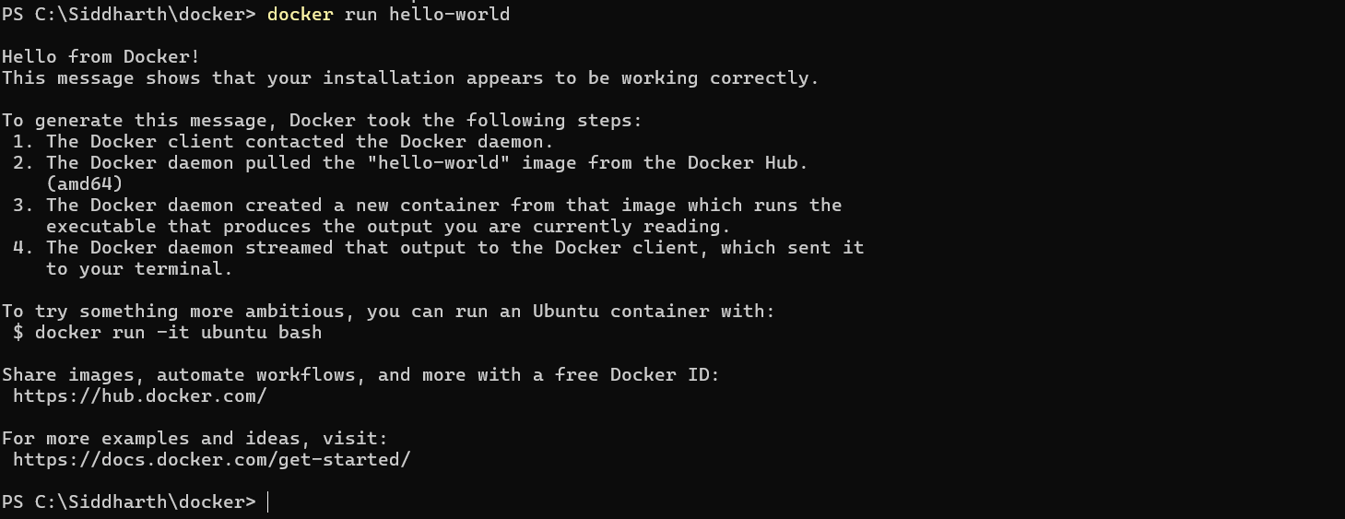

Step 2 :- docker ps -a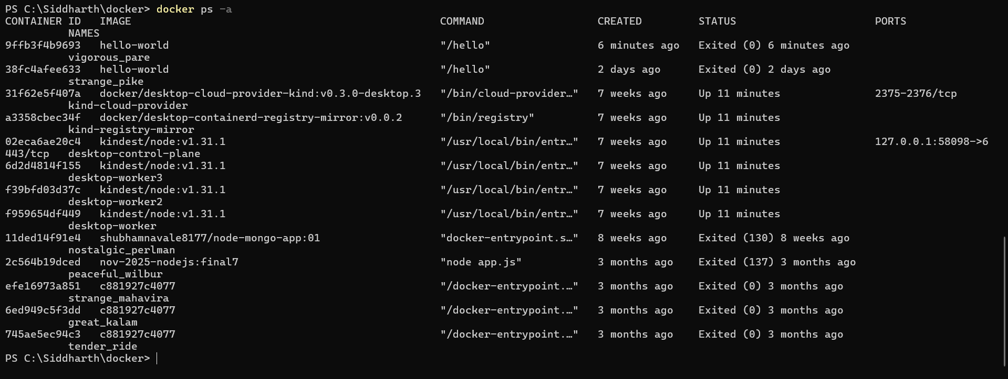

Step 3 :- docker image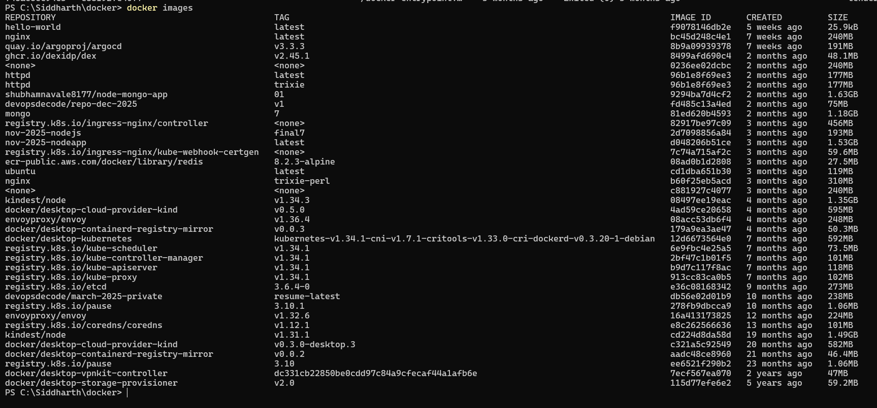

Step 4 :- docker run -it ubuntu bash
Ls , pwd , exit
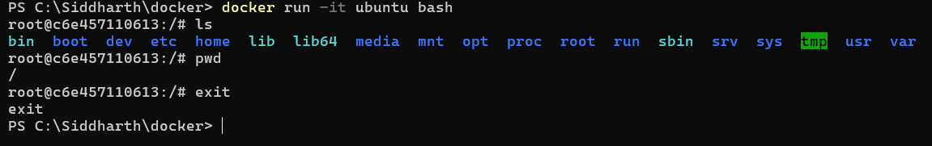

Stage 2 :- Multi-Container App

Step 1:- mkdir docker-assignment
cd docker-assignment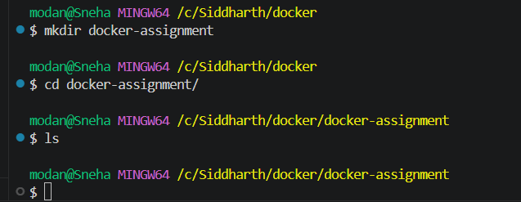

Step 2:- Create Compose File
Create file named :- docker-compose.yml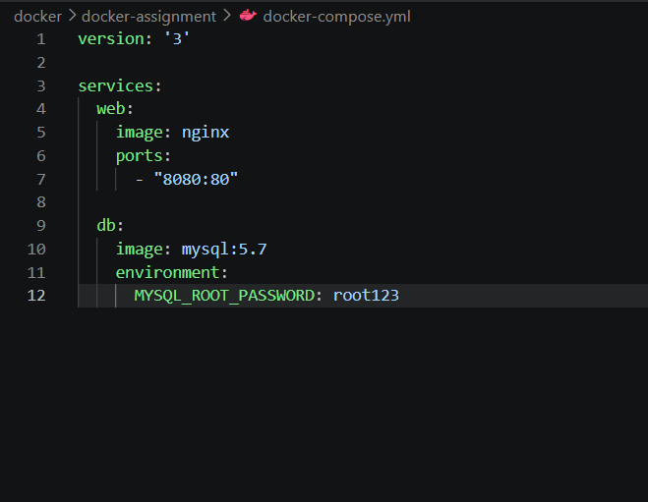
Step 3:- Start Multi-Container App
docker-compose up -d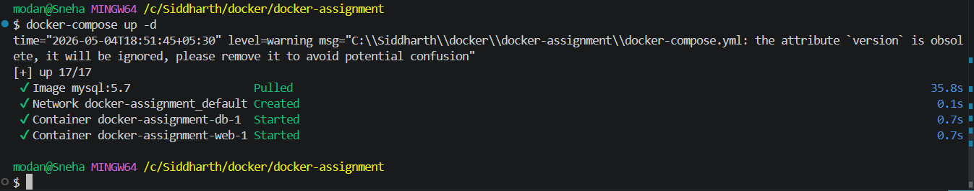
Step 4:- docker ps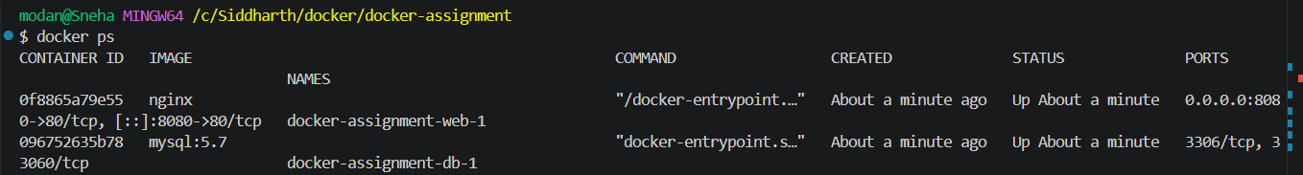
Step 5:- Open Website - http://localhost:8080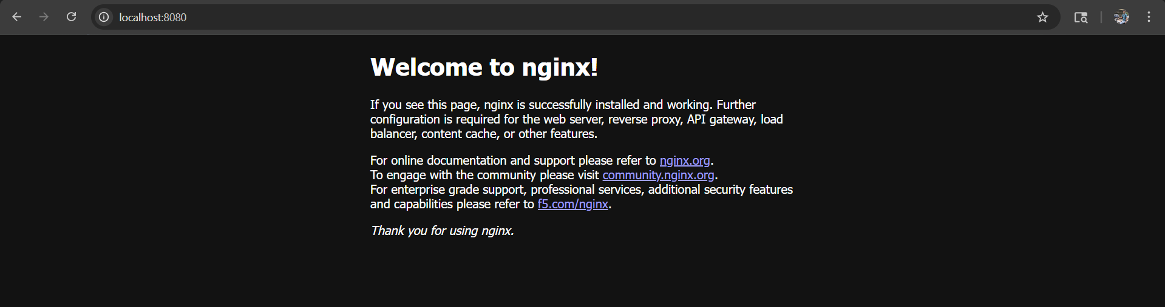
Stage 3 :- Networking and Orchestration
Step 1 :- Create dockerfile in the docker-assignment
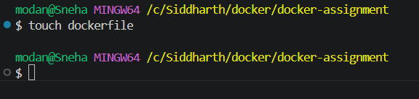

Step 2 :- docker build -t myweb .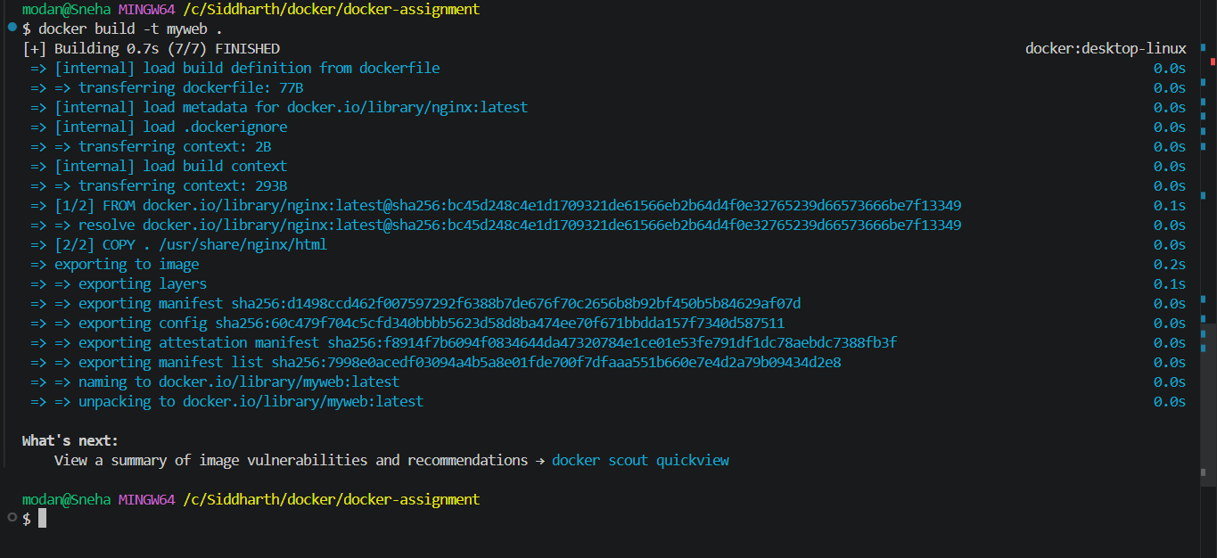

Step 4 :- docker images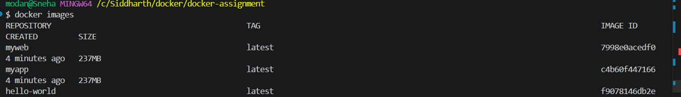
Step 5 :- docker run -p 8081:80 myapp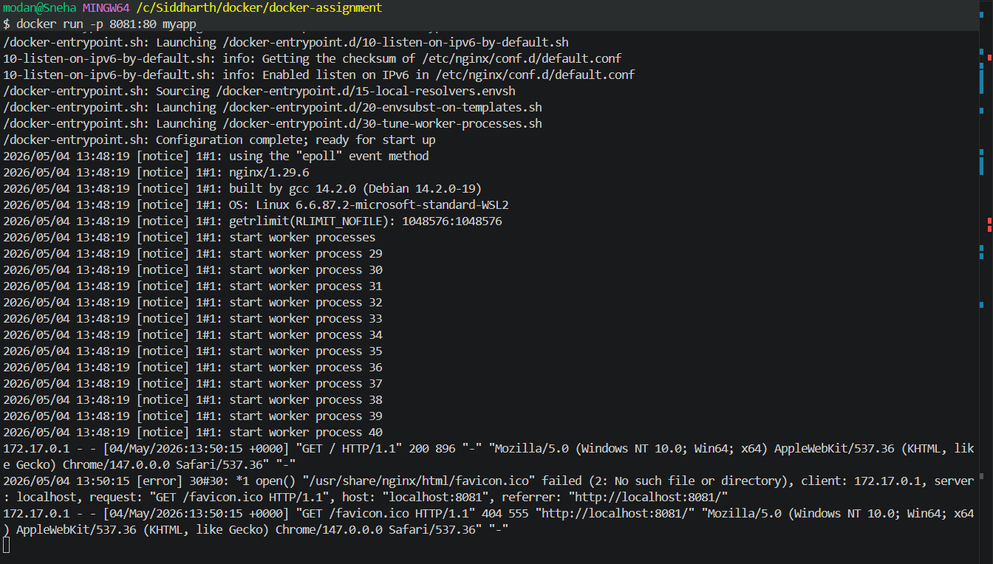

Step 6 :- http://localhost:8081